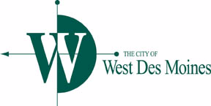

**PUBLIC WORKS COUNCIL COMMITTEE MEETING**

**AGENDA**

**Monday, November 9, 2015 – 11:30 AM**

Location: West Des Moines City Hall – Training Room

4200 Mills Civic Parkway

1. 88th & Ashworth – Traffic Signal Warrant Analysis (ERP)
2. White Crane Road, South 8th Street East To Dead End – Request for Contract Completion Extension (BJM)
3. Review of Public Works Items for Council Meeting (November 16, 2015)
   1. Accepting Work – 2015 Valley Junction Brick Paver Repair Program
   2. Approval of 28E Agreement – West Suburban Regional Traffic Signal Operations Group (RBH)
   3. Authorization to file Des Moines Area Metropolitan Planning Organization (MPO) Applications for Surface Transportation Program (STP) (JCC)
   4. Approving Professional Services Agreement
      1. 2014 Street Rehab, Sidewalk Ramp Program
      2. 2016 PCC Reconstruction Program
      3. Fire Station 18 Exterior Stairway Lighting
4. Staff Updates
   1. Special Speed Zones on Prairie View Drive / South Prairie View Drive (JVD)
5. Other Matters

***This agenda is created for planning purposes and is subject to change.***

Any discussion, feedback or recommendation by Sub-committee member(s) should not be construed or understood to be an action or decision by or for the West Des Moines City Council.