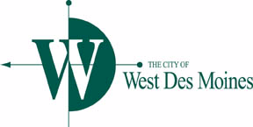

**PUBLIC WORKS COUNCIL COMMITTEE MEETING**

**AGENDA**

**Monday, November 23, 2015 – 11:30 AM**

Location: West Des Moines City Hall – Training Room

4200 Mills Civic Parkway

1. Modification to minutes of November 9th PWCC Meeting, Item 5.A (BH/DCW)
2. 2015/16 Snow Manual (RBH)
3. 2016 WDM Street and Parking Lot Rehab Projects (JLN)
4. 100 Block of 7th Street Access (JCC/JLN)
5. Notices for FEMA Map Revisions (DCW)
6. Transfer of Jurisdiction – Wendover Road (DCW)
7. Sanitary Sewer South Service Area Segment 2 (DCW)
8. Construction Status Update (DCW)
9. Review of Public Works Items for Council Meeting (November 30, 2015)
   1. Amendment to City Code– 2nd reading, waive 3rd reading, and adoption:
      1. Traffic Control - 88th Street and Ashworth Road west intersection
      2. Special Speed Zones – Prairie Drive – EP True Pkwy to Blue Stem Circle
   2. Approval of Traffic Code Amendment – No Parking Zones – Coachlight Drive, S. 84th Street to S. 88th Street – south side – 1st reading
10. Staff Updates
11. Other Matters

***This agenda is created for planning purposes and is subject to change.***

Any discussion, feedback or recommendation by Sub-committee member(s) should not be construed or understood to be an action or decision by or for the West Des Moines City Council.