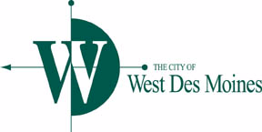**COMMUNITY COMPLIANCE**

**SUB-COMMITTEE MEETING**

***AGENDA***

Monday, January 23, 2017

4:30 p.m.

City Hall, Training Room

4200 Mills Civic Parkway

1. Review and approval of Minutes from October 31, 2016
2. Review Quarterly Report
3. Other Matters
4. Citizen’s Forum (each person will have 5 minutes to speak) – All

**THIS AGENDA IS CREATED FOR PLANNING PURPOSES AND**

**MAY BE SUBJECT TO CHANGE**

Any discussion, feedback or recommendation by Sub-Committee member(s) should not be construed or understood to be an action or decision by or for the West Des Moines City Council.

**Please bring agenda and all attachments to the meeting.**