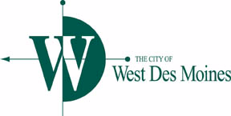**COMMUNITY COMPLIANCE**

**SUB-COMMITTEE MEETING**

***AGENDA***

Monday, July 15, 2019

4:30 p.m.

City Hall, Ashworth Room

4200 Mills Civic Parkway

1. Review and approval of Minutes from October 29, 2018
2. Review Reports
3. Other Matters
4. 2019 Sidewalk Program (Joe Cory)
5. Citizen’s Forum (each person will have 5 minutes to speak) – All

**THIS AGENDA IS CREATED FOR PLANNING PURPOSES AND**

**MAY BE SUBJECT TO CHANGE**

Any discussion, feedback or recommendation by Sub-Committee member(s) should not be construed or understood to be an action or decision by or for the West Des Moines City Council.

**Please bring agenda and all attachments to the meeting.**